**STUDENT MANAGEMENT SYSTEM**

DEPLOYMENT MANUAL

Step 1: Download the compressed project from the given GitHub link: Link: https:

Step 2: Open STS and import the downloaded file.

Step 3: Go to your application properties and change the credentials according to your system.

Step 4: The port number we have given is 8090, if this port is busy, change the port number.

Step 5: Run the project as spring boot application as shown in the picture below.

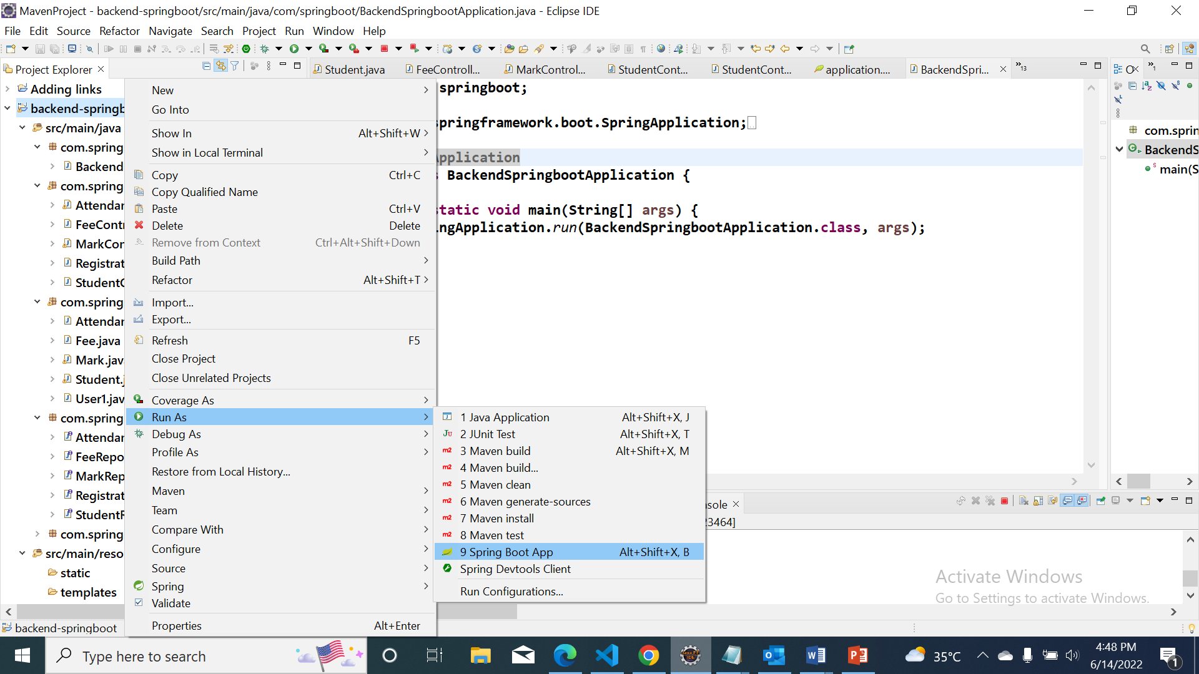

Step 6: Once, it shows login registration application has started in the console, open up your web browser and type localhost:8090/ (or localhost: port number/)

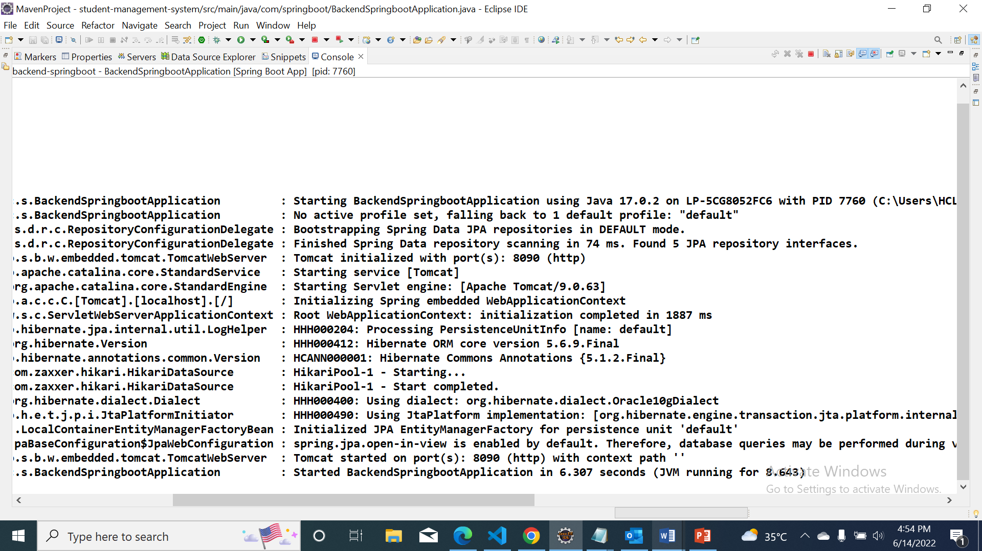

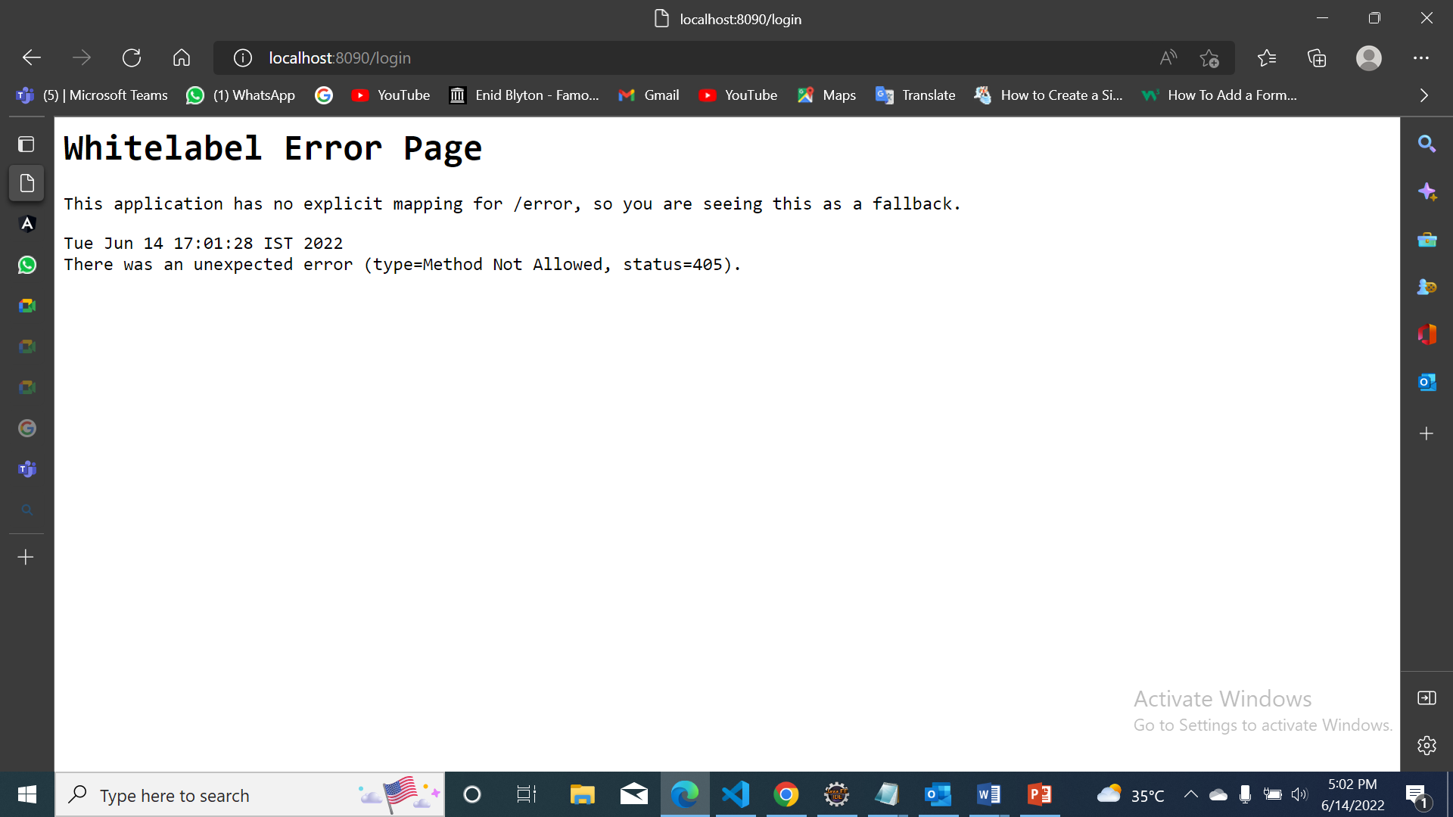

Step 7: ***Once it gets loaded, main page of the site gets opened up. Here you to provide the Admin credentials if existing.***

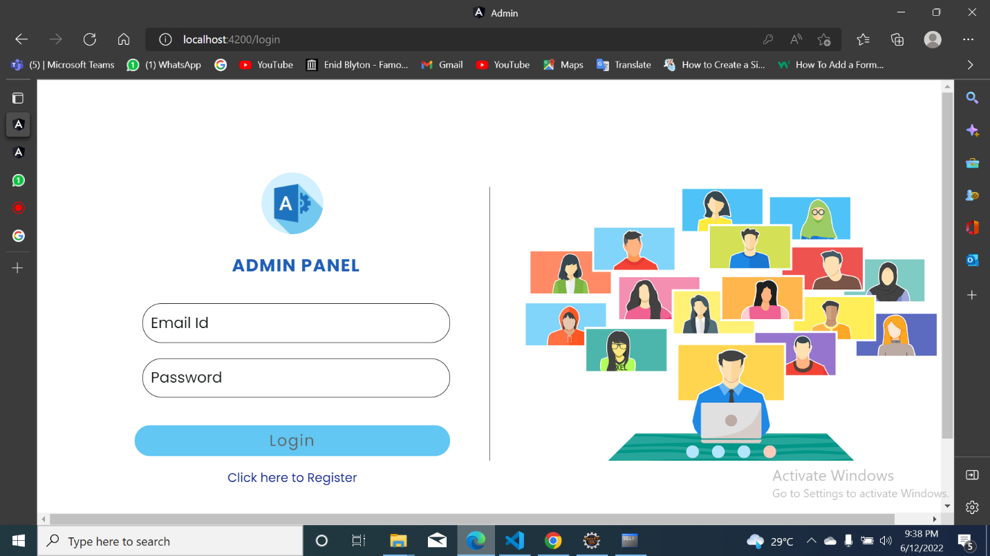

Step 8: ***if not, register in the page below.***

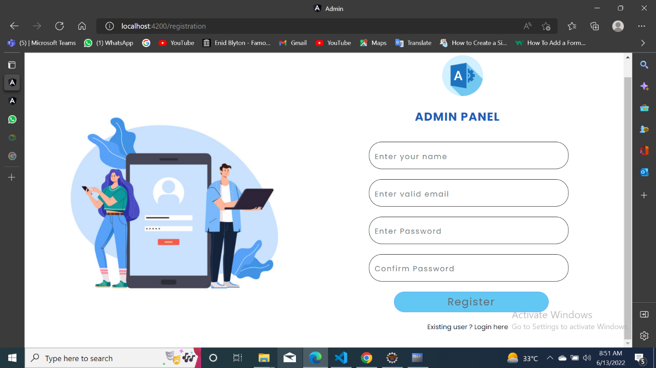

Step 9: ***Once registered, same process of login should be done. And home page opens***

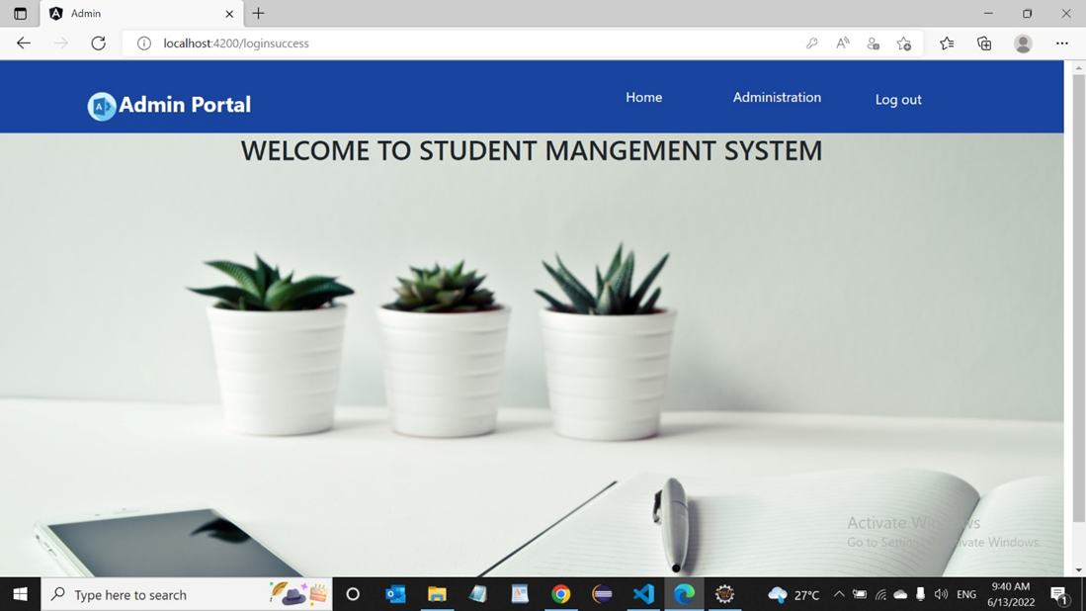

Step 10: ***The are three buttons in the header. Firstly ‘home’ which represent the current homepage***

***Secondly, ‘administration’ has submenu as shown below.***

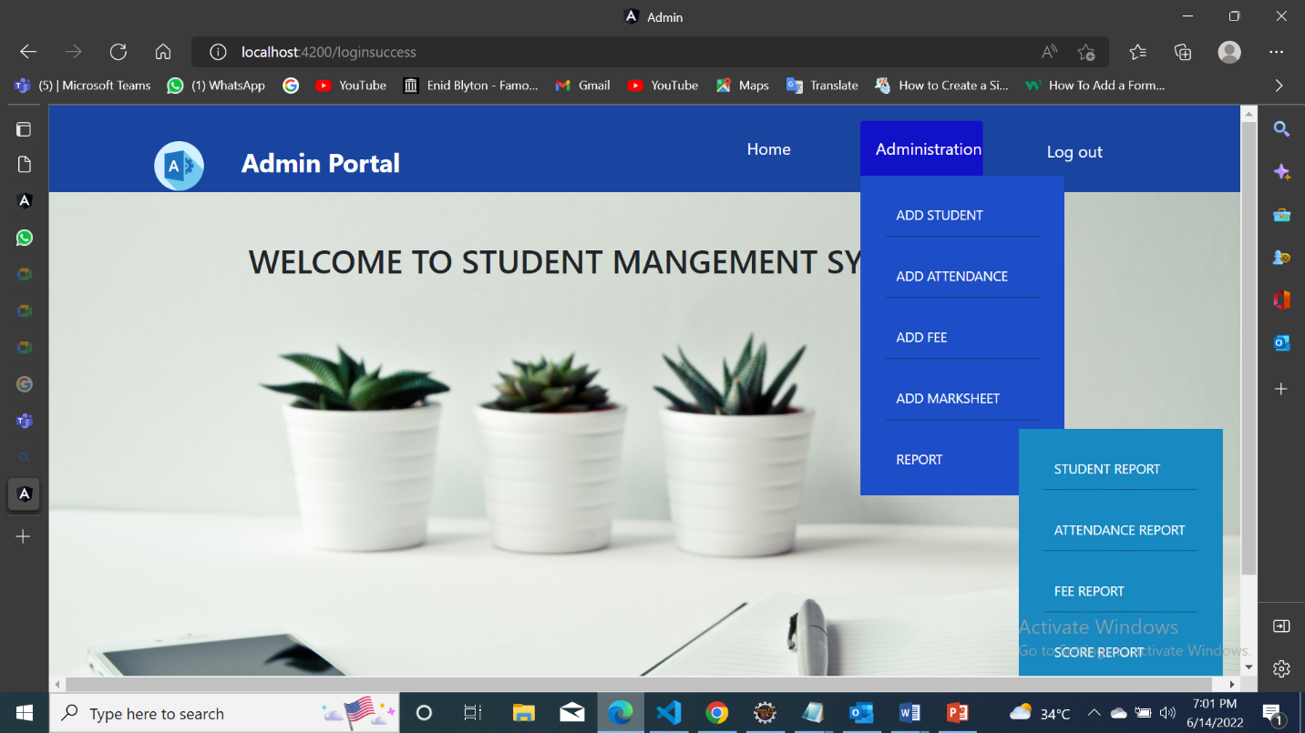

Step 11: ***On clicking ADD STUDENT ,***

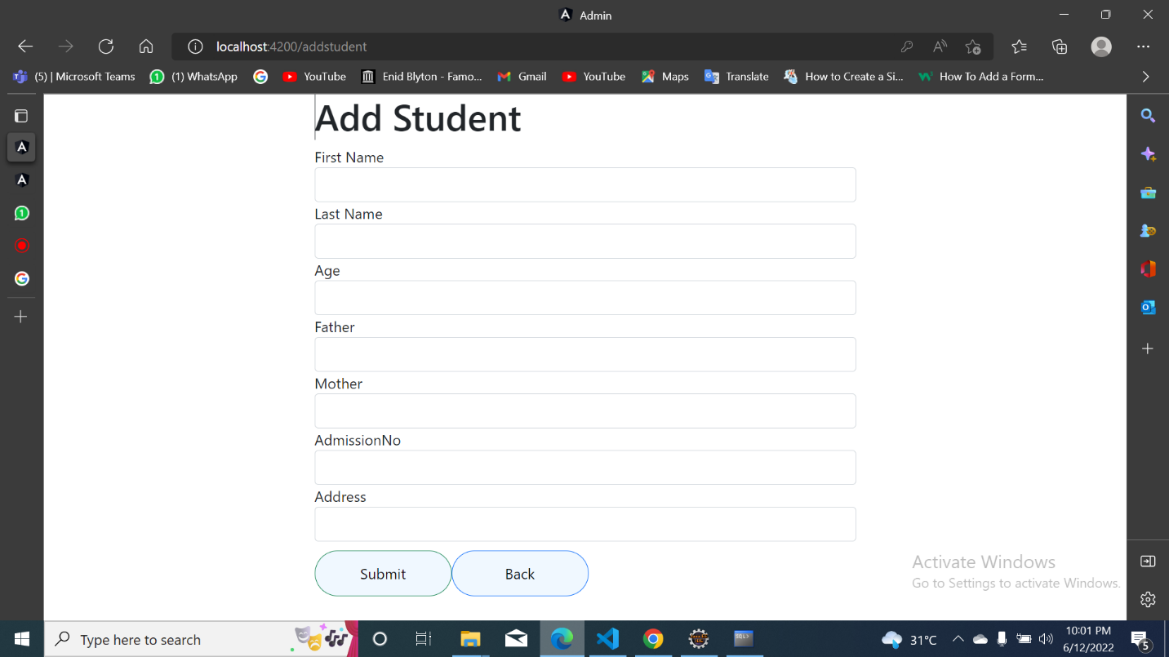

***After entering the student details, click Submit. To take took at student report. Click on administration> REPORT> STUDENT REPORT button in submenu , opens.***

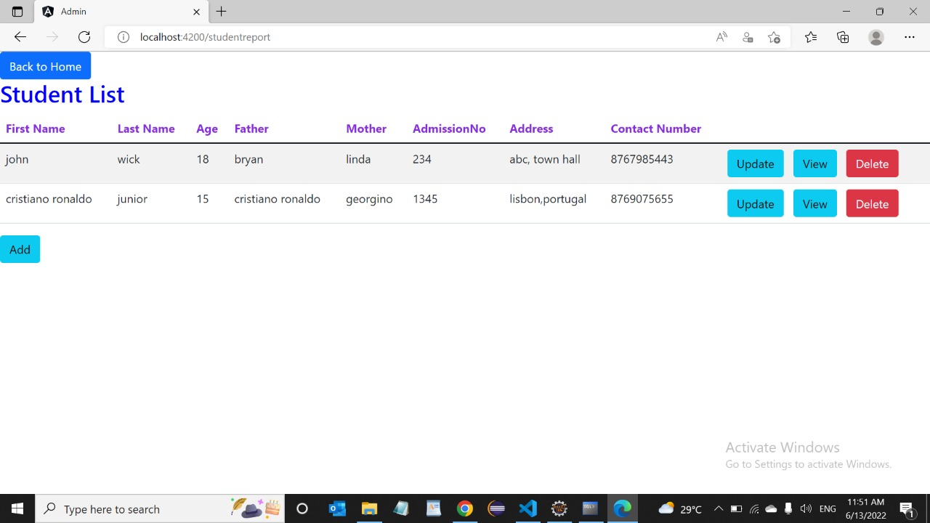

***Here you can edit student details by clicking update , view , detail buttons .***

Step 12: ***On clicking ADD ATTENDANCE,*** 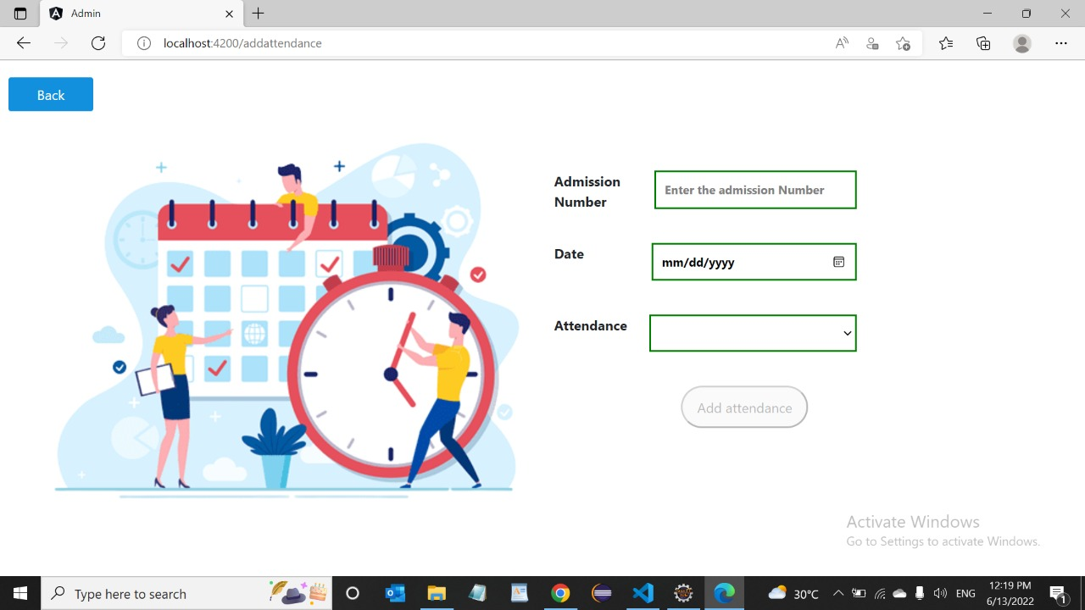

***After entering the attendance details, click add attendance. To take took at attendance report. Click on administration> REPORT > ATTENDANCE REPORT button in submenu , opens.***

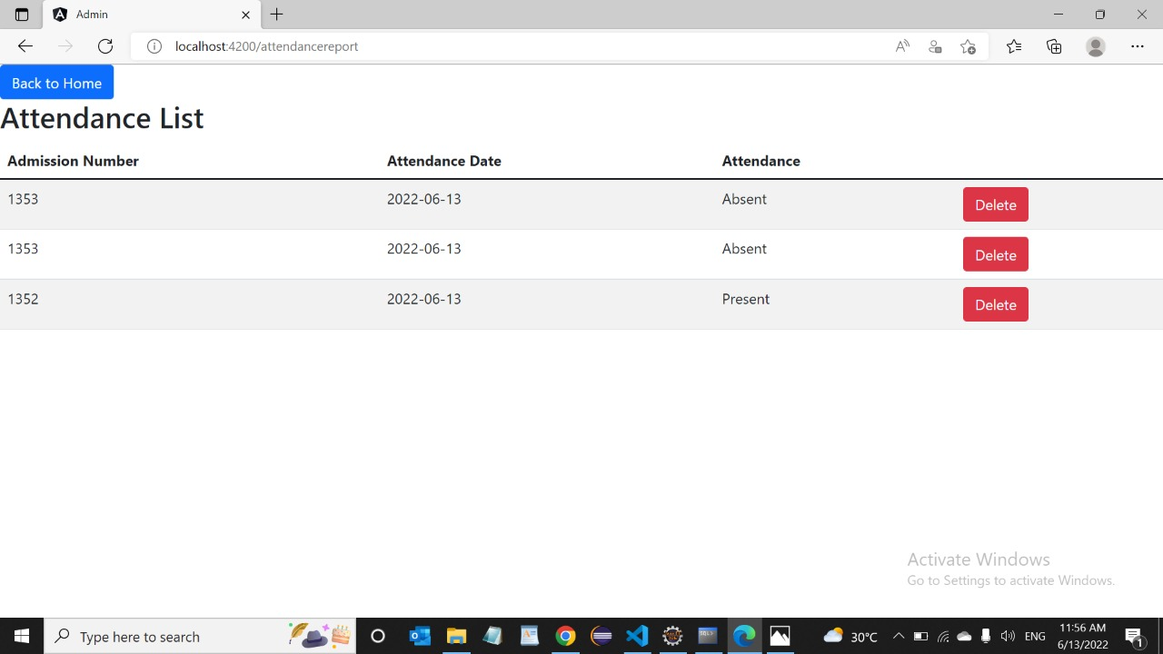

***Here you can edit student details by clicking detail button .***

Step 13: ***On clicking ADD FEE,***

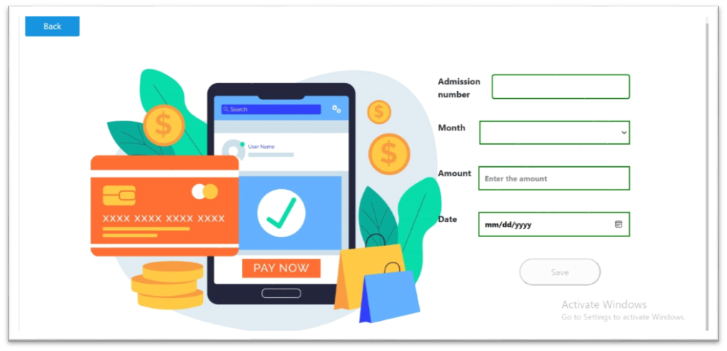

***After entering the fee details, click Save. To take took at fee report. Click on administration> REPORT > FEE REPORT button in submenu , opens.***

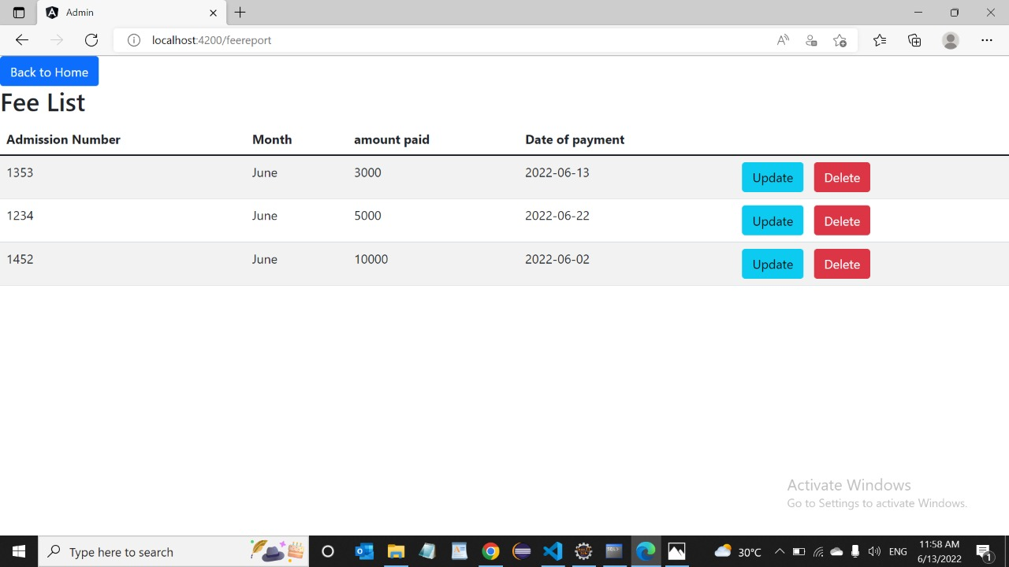

***Here you can edit student details by clicking update, detail buttons .***

Step 14: ***On clicking ADD MARKSHEET,***

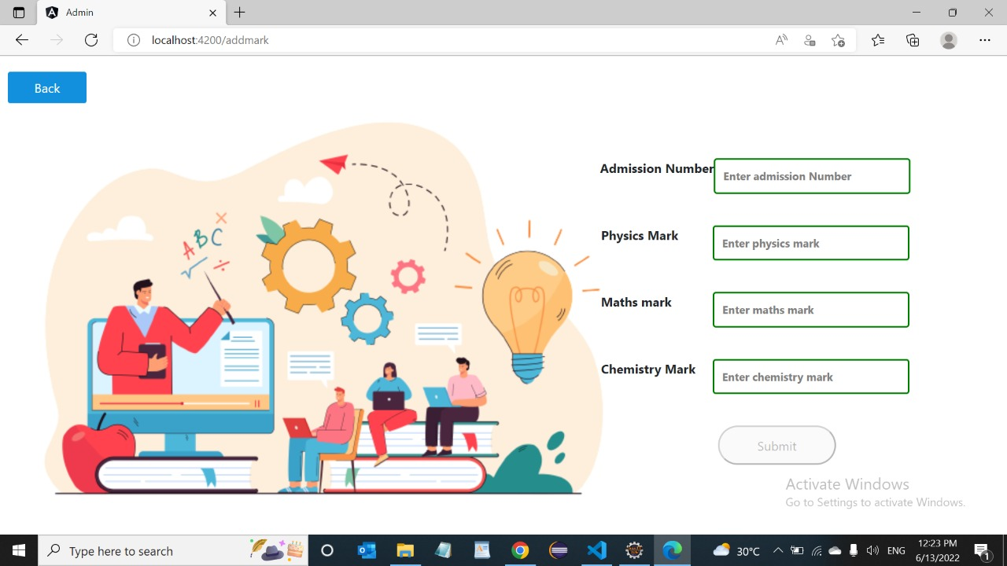

***After entering the mark details, click Submit. To take took at mark report. Click on administration> REPORT > SCORE REPORT button in submenu , opens.***

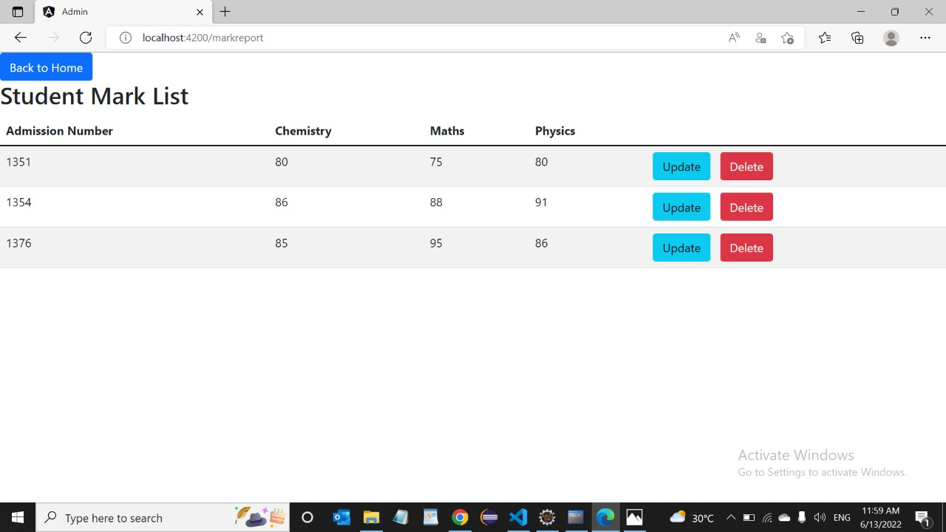

***Here you can edit student details by clicking update, detail buttons .***